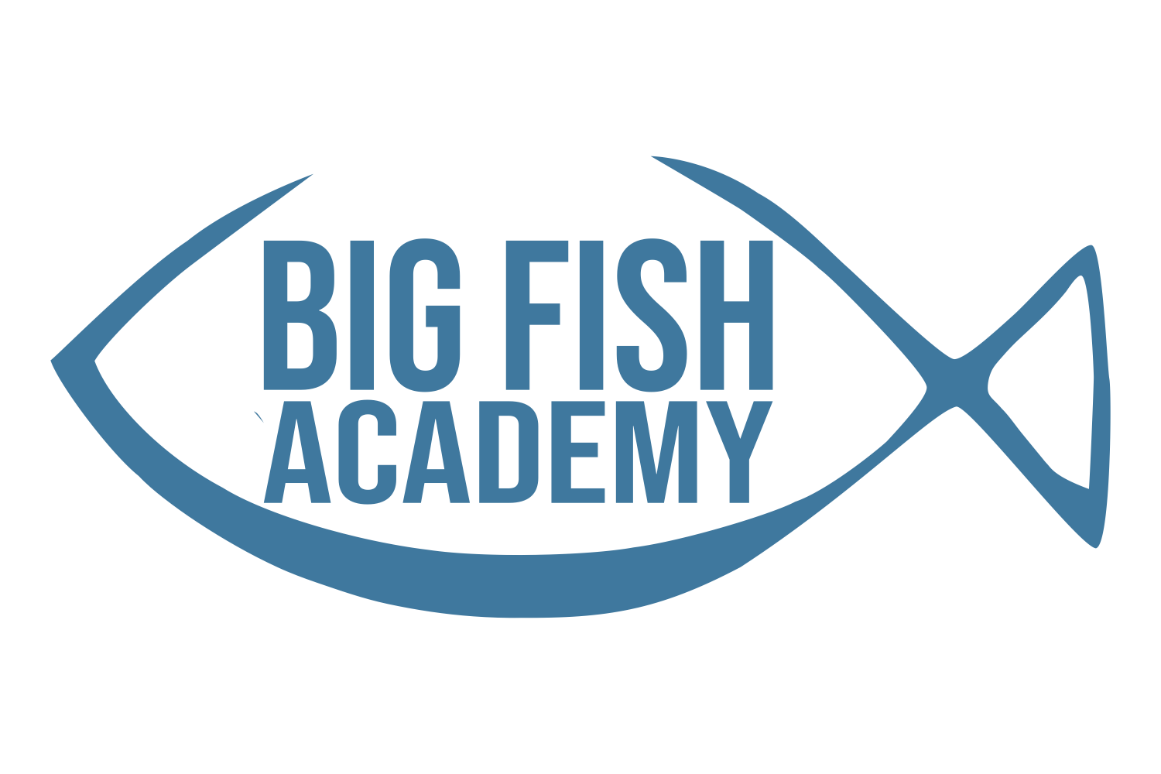

**3 Year Old Class Supply List**

**Required Items**:

* 2” thick rest mat
* 1 fitted crib sheet (for rest time)
* 1 small blanket (for rest time)
* 1 FULL SIZE backpack (no small preschool backpacks please)
* 1 set of extra clothes:shirt, shorts/pants, socks, and underwear (seasonally appropriate). Please label all items and place in a labeled gallon ziploc bag
* Lunch box, labeled with child’s full name
* Water bottle labeled with child’s full name (No sippy cups please)

**Supply Needs:**

* 1 Plastic RED two pocket folder with prongs
* 2 packs Crayola 10 ct Broad washable Markers (primary colors please)
* 1 plastic school/pencil box
* 1 bottle Elmer’s School Glue
* 1 Crayola watercolor paint set
* 1 24 count Crayola Crayons
* 4 containers Play-Doh
* 1 pack Multi-Color Cardstock (Girls Only)
* 1 pack White Cardstock (Boys Only)
* 1 pack Expo Dry Erase Markers
* 1 Box Facial Tissues
* 1 container Lysol Wipes
* 2 4ct Elmers Glue Sticks
* 1 Box Plastic spoons (Girls Only)
* 1 Box Plastic Forks (Boys Only)
* 1 Box Quart Size Ziploc Bags (Girls only)
* 1 Box of Gallon Size Ziploc Bags (Boys Only)
* 2 Packages of Baby Wipes
* 4ct Ticonderoga My First Jumbo Pencils
* 1 box bandaids
* 1 bottle hand soap

**Appropriate Dress for Preschool**

Part of creating childhood means FUN! When choosing your child’s clothing, bear in mind that sometimes our fun can be messy! For this reason, please follow our clothing policies to ensure your child has the best experience.

**Shoes**

Children (toddler and up) will wear tennis shoes (with socks) or shoes that are rubber soled. The foot should be totally enclosed in the shoe. This is for your child's safety during active play. Clogs, Crocs or 'Croc style shoes' will require a heel strap to be worn at school.

Children should not wear:

1. shoes with Squeaker-action (usually a toddler style shoe)

2. 'heeley’ style or other skate shoes

3. cowboy boots

4. house shoes

5. sandals

6. clogs or dress shoes with slick bottoms

7. any shoe that is disruptive, or could cause a child to have accidents

**Clothing**

Children should wear comfortable clothing. Clothing should be easy for him or her to button, zip, and slip on and off easily. Pants with elastic waistbands are the best. This allows children to have the advantage of speed when making it to the potty.

Garments with buckles, snaps, and belts are difficult to manipulate. Precious time is

used up, if the child has to ask the teacher for assistance. Daily activities include active and messy play. Children should feel comfortable enough to enjoy themselves without worrying about their clothes.

Undergarments are a requirement for modesty reasons and for the prevention of waste escaping clothing when accidents occur. When wearing dresses or skirts, children need to wear bloomers or shorts that cover their underwear. This ensures modesty during active play indoors and out.

Children may not wear necklaces (including teething necklaces), bracelets, or watches.

**Dressing for Weather**

Please dress your child in seasonally appropriate and comfortable play clothes.

In accordance with DHS licensing requirements, All children will be going outside each day when the temperature is 32°F-95°F, depending on wind, sunshine, air quality, and heat index. During the summer months, we will have water play. We will notify you of the times for water play so that you may provide a swimsuit, secure water shoes, and towel.

**Change of Clothing**

Each child should have at least one, preferably two complete changes of seasonally appropriate play clothing, including socks and shoes, in his or her cubby at all times. (The number of spare sets needed may increase during potty training.) Please be sure to replace any articles of clothing that are used from the spare set.

**Label Everything**

Please label ALL items (including clothing, coats, hats, bottles, baby food, bags, and sippy cups) that you bring to the school with your child’s first and last name.

**Bringing Toys from Home**

Children should leave their personal toys at home. You may bring a soft security item, such as a blanket, stuffed animal, or doll that your child needs for naptime. This item must be labeled. Please let your child know that the item will stay in their cubby until nap time and will be returned to the cubby after naptime.

If a “show and tell” day is planned for the children, check with the teacher to see what type of items would be best to bring. Any items brought for a special reason requested by teachers need to be labeled appropriately with the child’s first and last name. Labeling all of your child’s items is the best way to ensure they do not get misplaced.

We are not responsible for personal items or toys from home that get lost or broken.

Big Fish Academy may prohibit items coming to school that are a classroom distraction. Items that are expressly forbidden include: trading cards of any type, weapons, handcuffs, nail polish, make-up, and lipstick.

**Food Service:**

The children at Big Fish Academy bring their own lunches to school. The children are to bring selections of fruits, vegetables, and milk products for a balanced lunch.

We are unable to microwave, refrigerator, or prepare meals. All items must be ready to consume out of the lunchbox. A cold pack is needed in all lunches that require cold storage.A child will not be forced to eat. Food will not be withheld from a child. Children will be given adequate time to eat. Food will not be used as a reward. Any food that is served to your child during lunch will either be eaten by your child or thrown away if not eaten. We know this sounds wasteful, but per DHS, after food has been served, we can no longer guarantee the integrity or the quality of the food and must throw away any waste. We recommend only sending any items that you know your child will eat and in quantities you know they will eat.

**Allergy Information Form**

You have been asked on the registration form for detailed information on your child’s allergies. If a new allergy arises while in our care, please let your child’s teacher and the BFA leadership team immediately.

If your child’s allergy is life threatening, an Allergy Action Plan from the child's doctor is required. Please email us at office@campbigfish.org to obtain a blank allergy action plan to give to your child’s doctor. An Allergy Action Plan from your child’s MD can be sent to us via fax at 615-822-5456 or email [hbfaoffice@campbigfish.org](mailto:hbfaoffice@campbigfish.org).